**USER MANUAL**

**FOR**

**CODEWORD GENERATOR**

**(ANGULAR)**

**Table of Contents**

General Information 3

System Configuration 3

User Access Levels 3

Getting started with step-by-step guide of web application 4

Demonstration 6

**General Information:**

Codeword generator is a web application. This application will be used by the professor and students in a browser

**System Configuration**

A desktop/laptop, computer or any mobile having access to internet via a web browser

**User Access Levels**

There will be a web app with roles for: (1) professors, (2) students. Students will be able to retrieve their code word for a specific course survey. A Student will be able get repeated access to the code word for a course over an extended period. Professors will be able to set an expiration date (generally the last day of the term). This can default to 4 months from the date of creation. Professors will be able to create a list of code words to be assigned to students in a course. Professors will be able to anonymously assign code words to students. Professors will be able to monitor that students in a class have received a code word, but not be able to determine what the code word is. Professors will be able to use the application to assign code words for concurrent surveys in different courses, and different sections active at the same time. Therefore, students may have multiple code words during a term

**Getting started with step-by-step guide of web application**

**Steps covered below:**

1. Login to web application by launching the application using a browser

i) Register as Instructor with email-id and password.

ii) Enter the email-id and password.

iii) A confirmation message will be shown as a pop-up

2. Creating a new course by filling details

i) Entering the course name

ii) Selecting Start Date and End Date

iii) Selecting the upload button to upload list of students

iv)Selecting Codeword set

v) Entering the urls of the Survey

vi) Clicking the create button to create course

vii) Creating of course with the pop conformation

3. View Dashboard

4. View Codeword Set

i) Creating a sample codeword set

ii) Choosing the sample codeword set

iii) Details of the sample codeword set being shown, before clicking create button

iv) Pop-up showing the creation of sample codeword

v) Creation of sample codeword set

vi) Detail view of the sample codeword set

5. Viewing the course

i) View of the Course

ii) Editing of the course related details

iii) Editing of Student related details

iv) Option to delete the student details

v) Option to delete the course details

5. Viewing the acknowledge Status

i) Acknowledge Status before Student Viewing the status

6. Register as Student with email-id and password.

i) Enter the email-id and password.

ii) A confirmation message will be shown as a pop-up

iii) View of Student Dashboard showing courses and hidden codeword

iv) Reveling of codeword of Android course by clicking Reveal Codeword button

7. Re- Viewing the acknowledge Status

i) Acknowledge Status after Student Viewing the status

8. Logging Out of the website

Demonstration:

**Step 1:** Login to web application by launching the application using a browser

1. Register as Instructor with email-id and password.

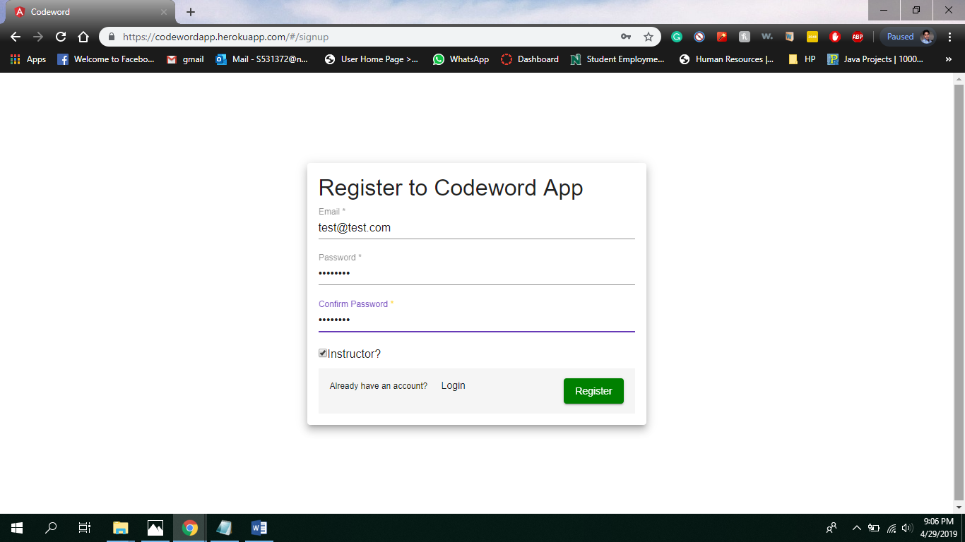

1. Enter the email-id and password.

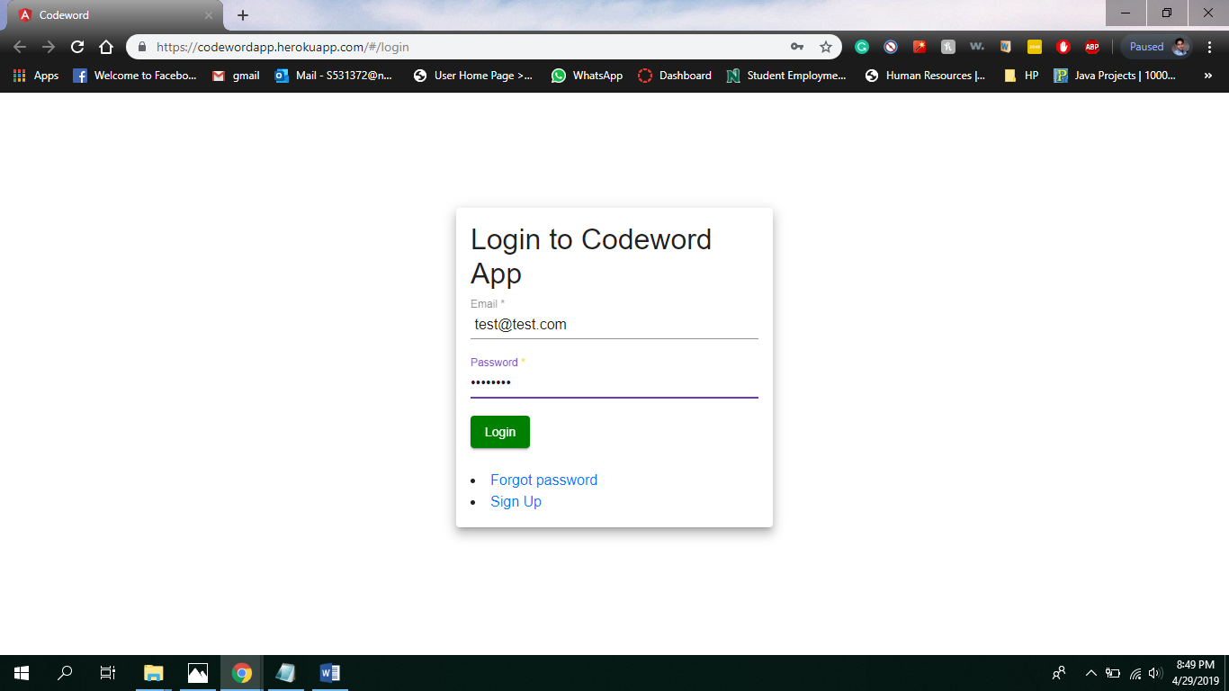

1. A confirmation message will be shown as a pop-up

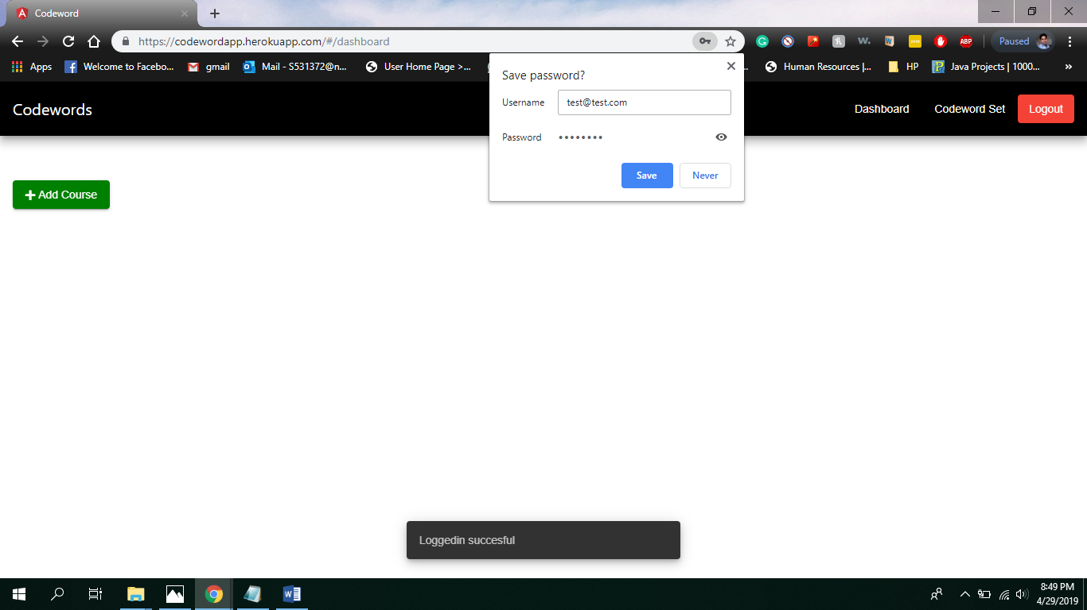

**Step 2 :**

1. Creating a new course by filling details
2. Entering the course name

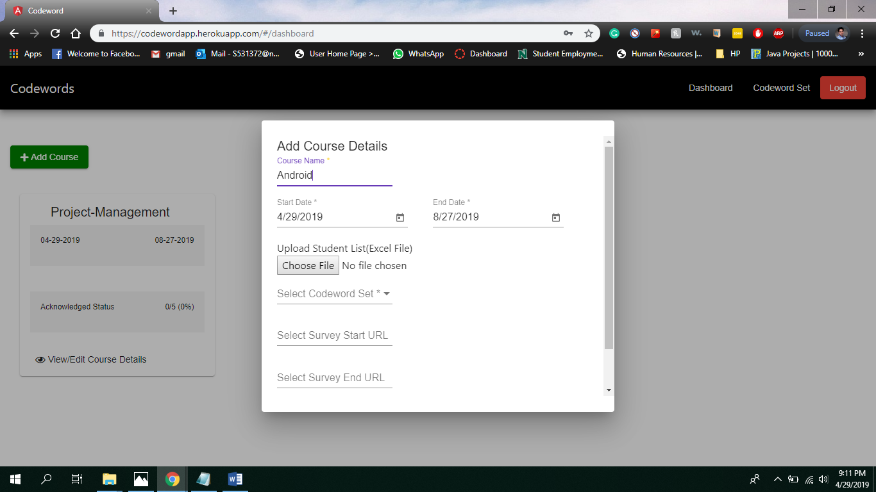

ii)Selecting Start Date and End Date

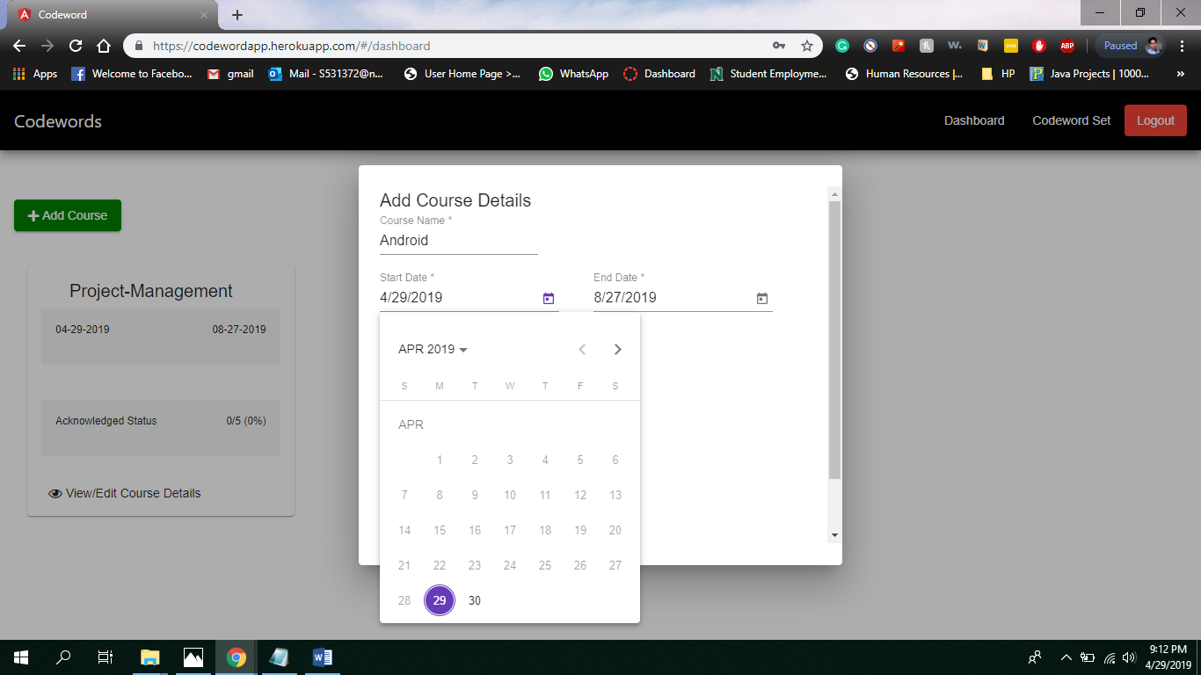

iii) Selecting the upload button to upload list of students

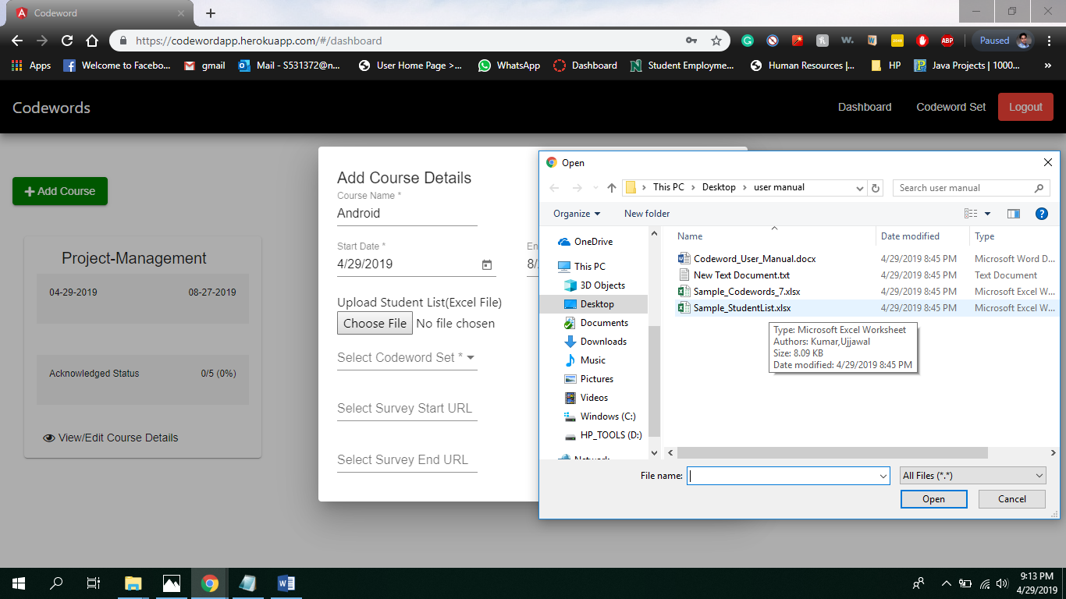

iv)Selecting Codeword set

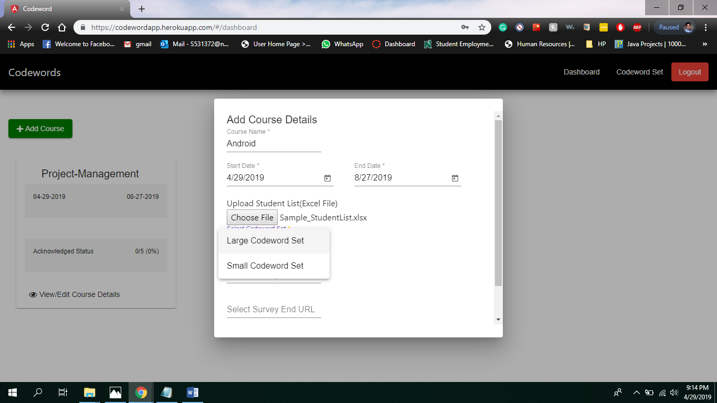

v) Entering the urls of the Survey

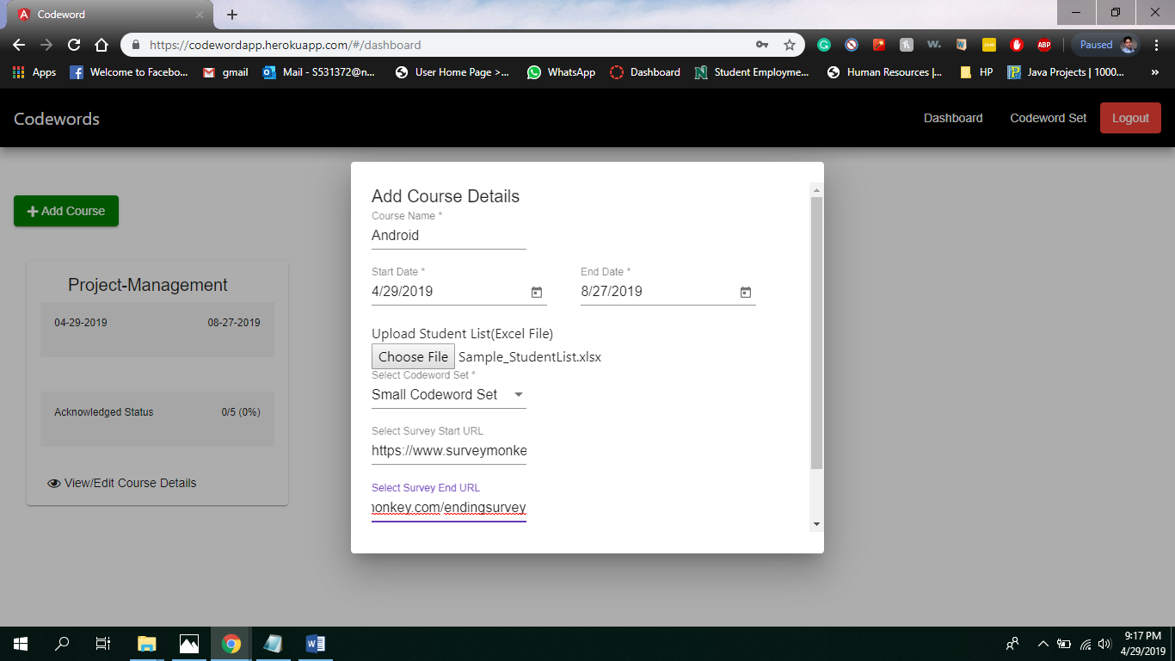

vi)Clicking the create button to create course

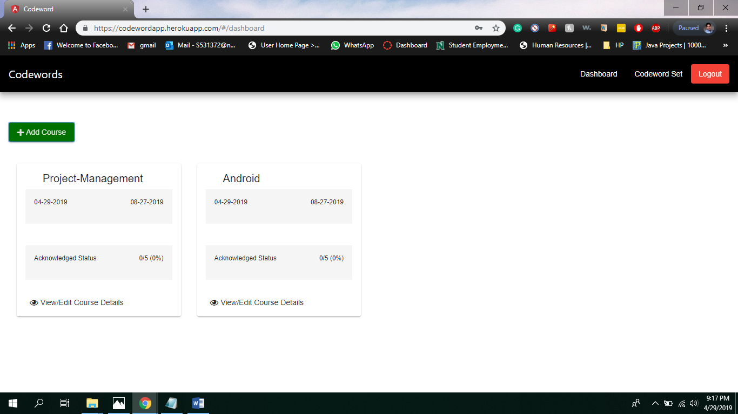

vii) Creating of course with the pop conformation

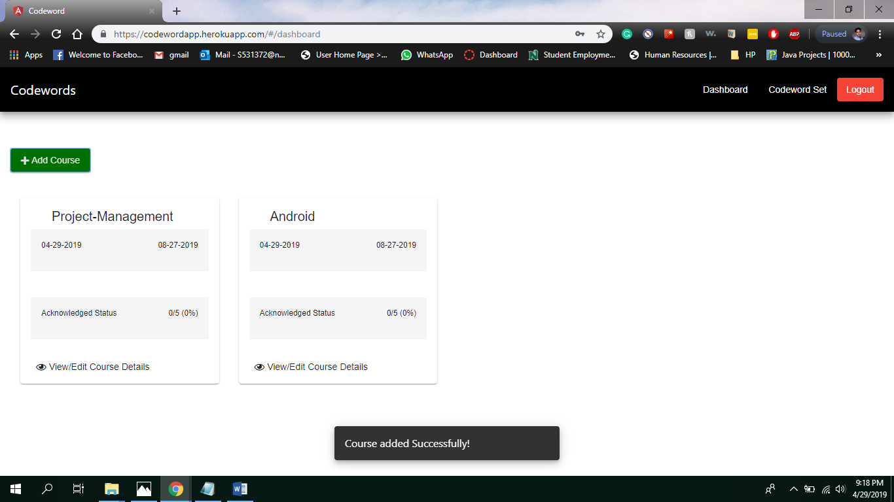

**Step 3: View Dashboard**

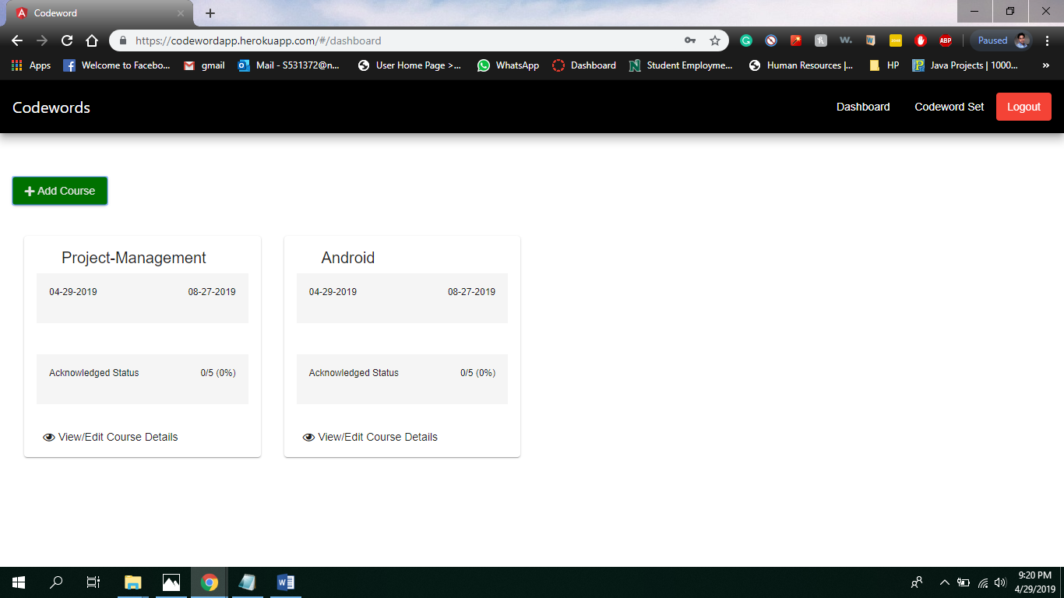

**Step 4: View Codeword Set**

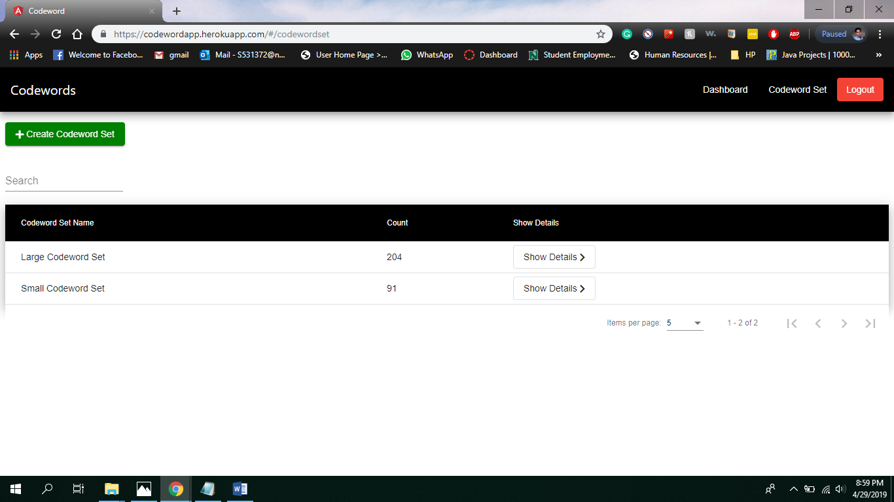

1. Creating a sample codeword set

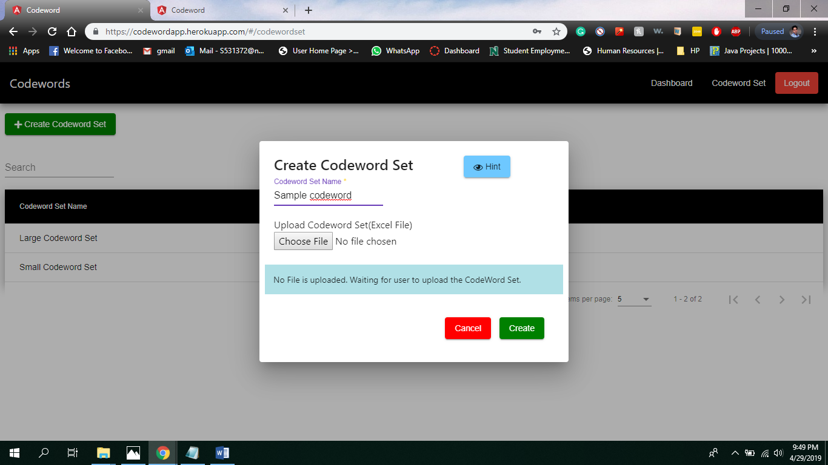

1. Choosing the sample codeword set

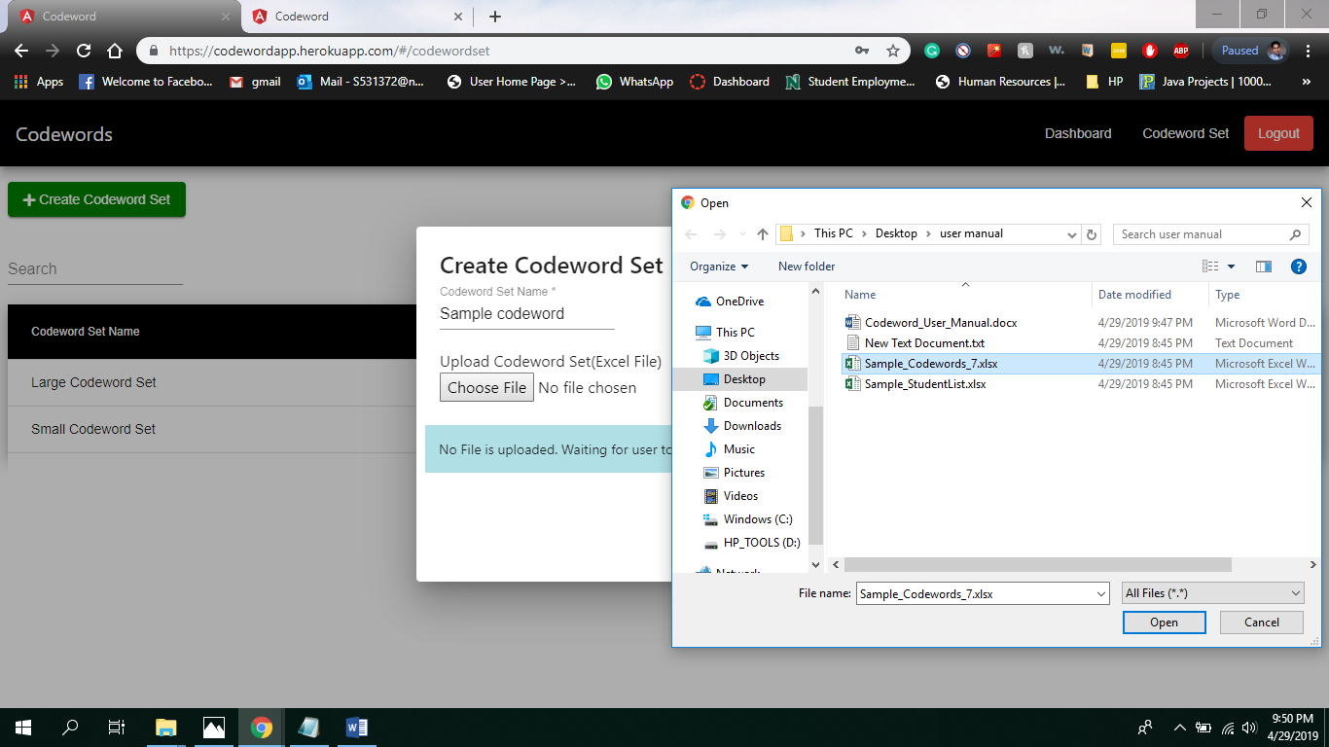

1. Details of the sample codeword set being shown, before clicking create button

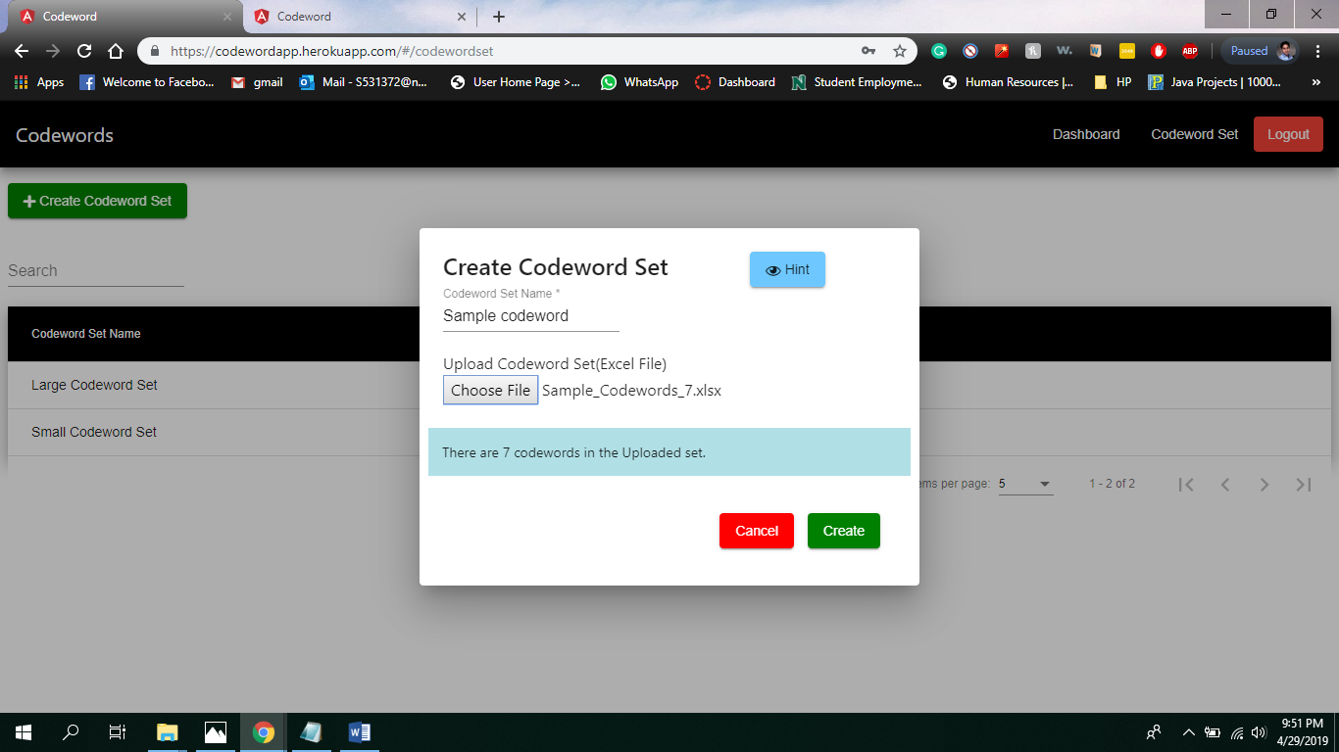

1. Pop-up showing the creation of sample Codeword

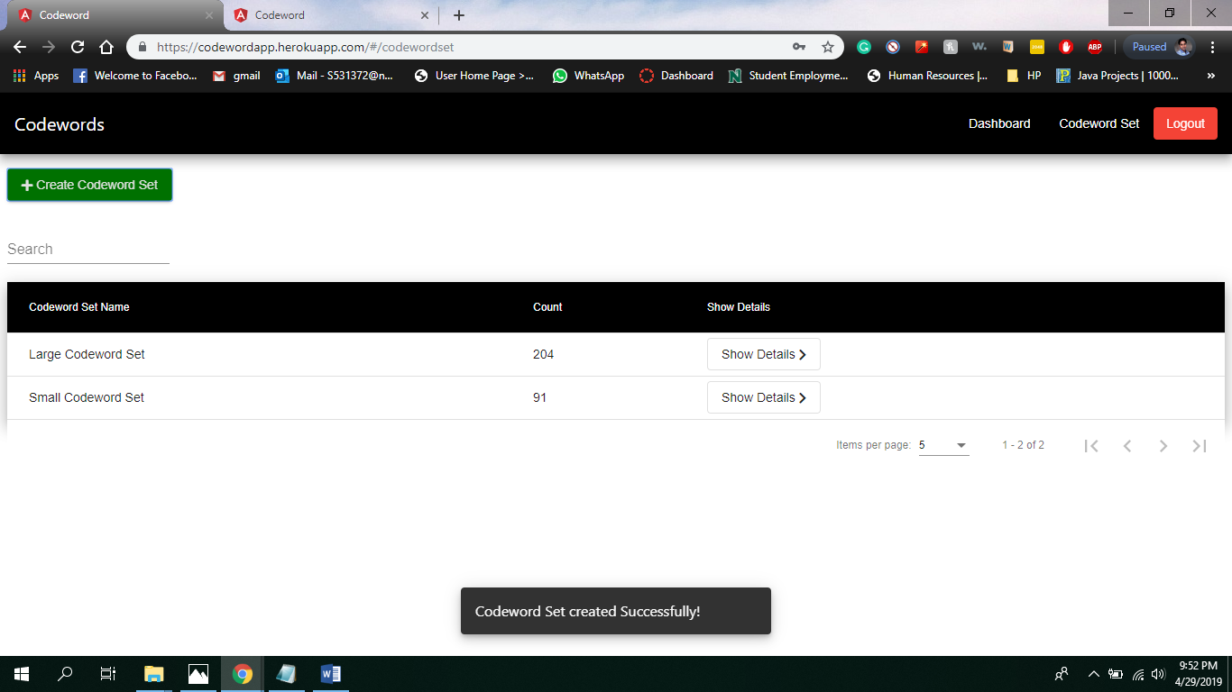

1. Creation of sample codeword set

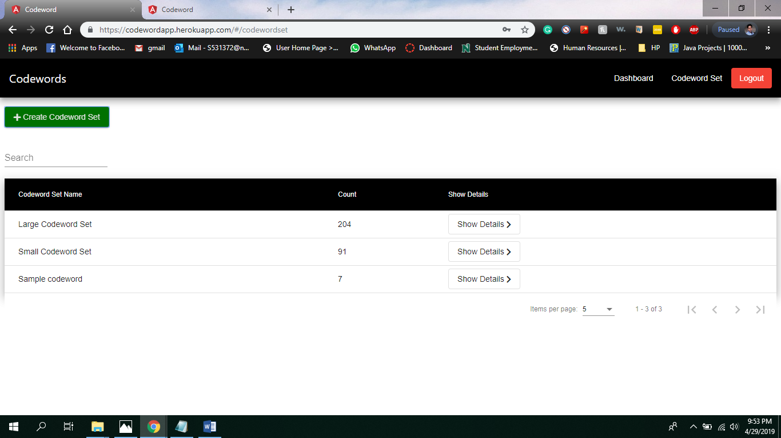

1. Detail view of the sample codeword set

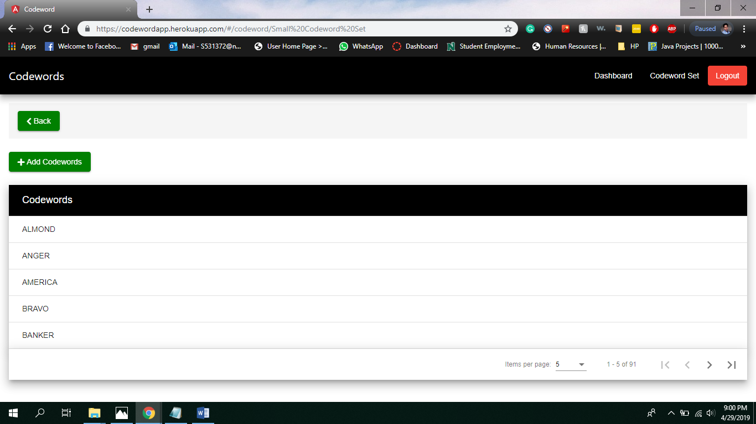

**Step 5 : Viewing the course**

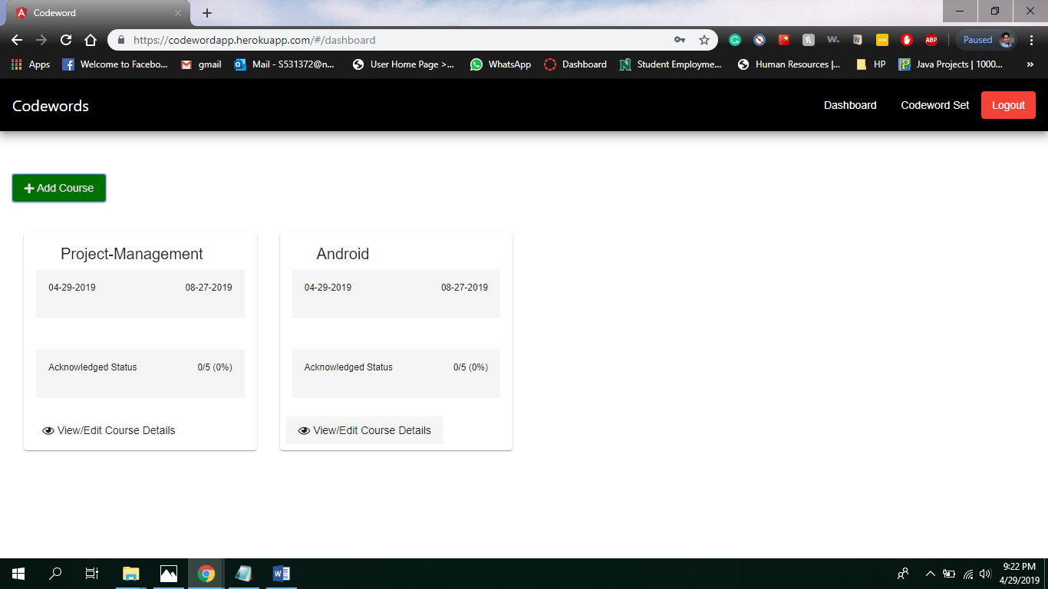

1. View of the Course

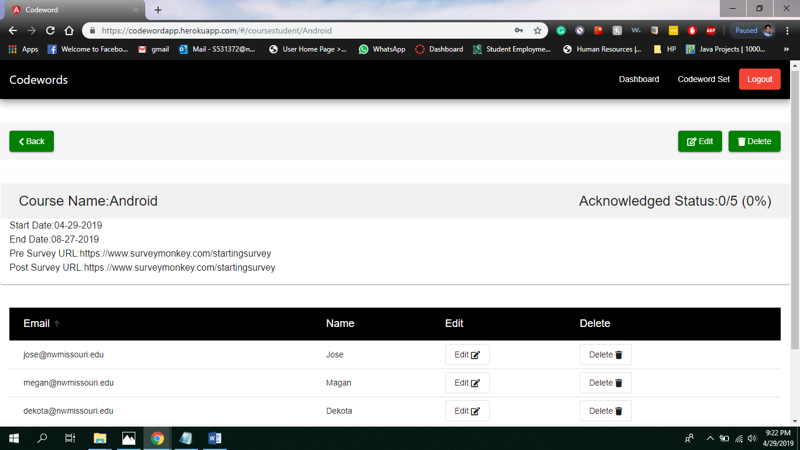

1. Editing of the course related details

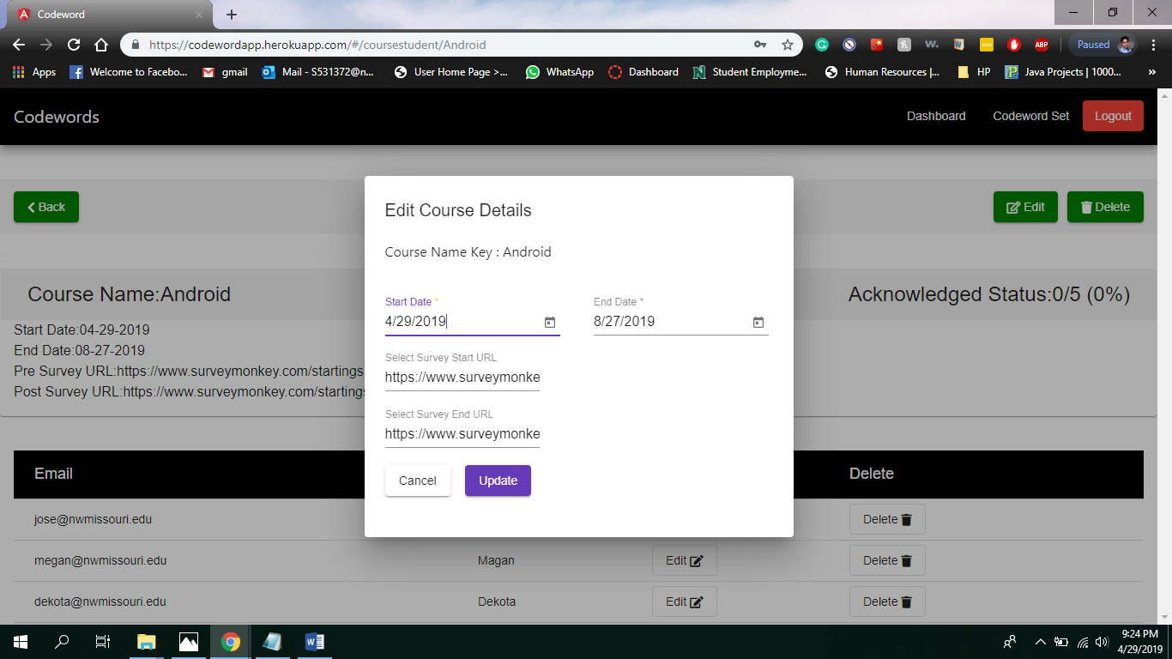

1. Editing of Student related details

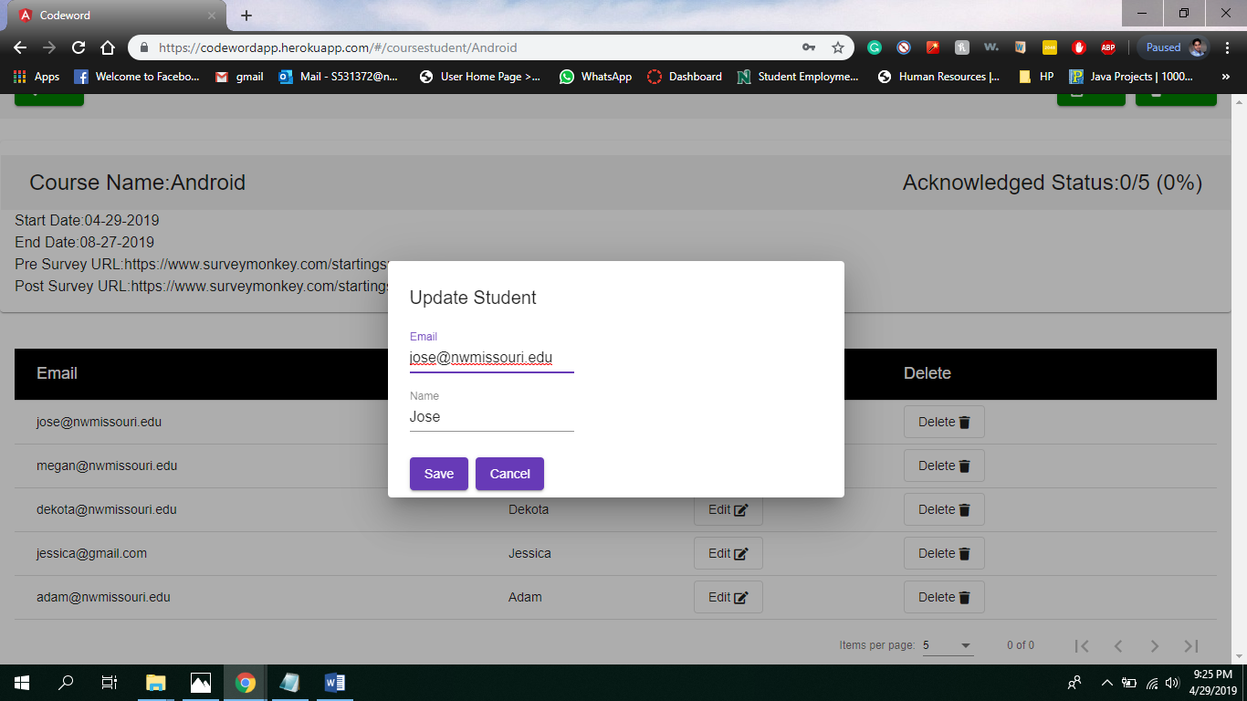

1. Option to delete the student details

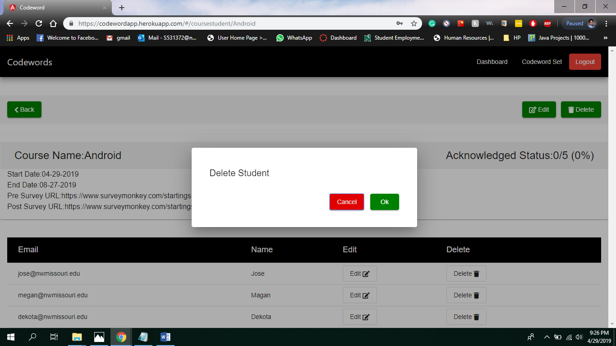

v)Option to delete the course details

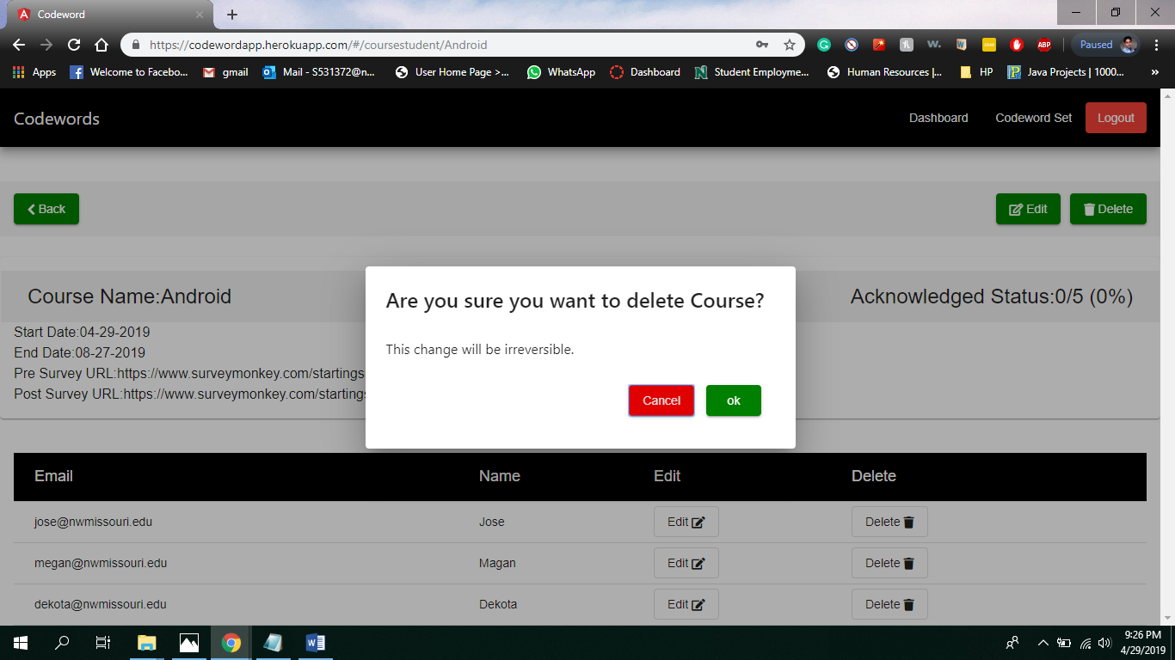

**Step 5 : Viewing the acknowledge Status**

Acknowledge Status before Student Viewing the status

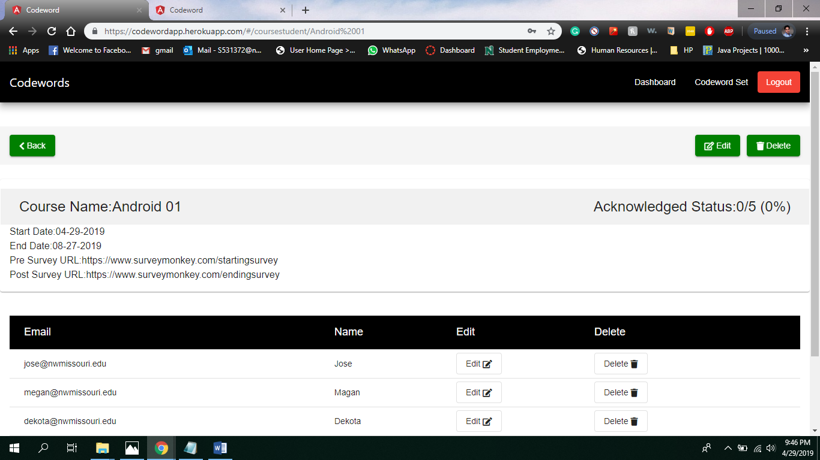

**Step 6:**

**i)**Register as Student with email-id and password.

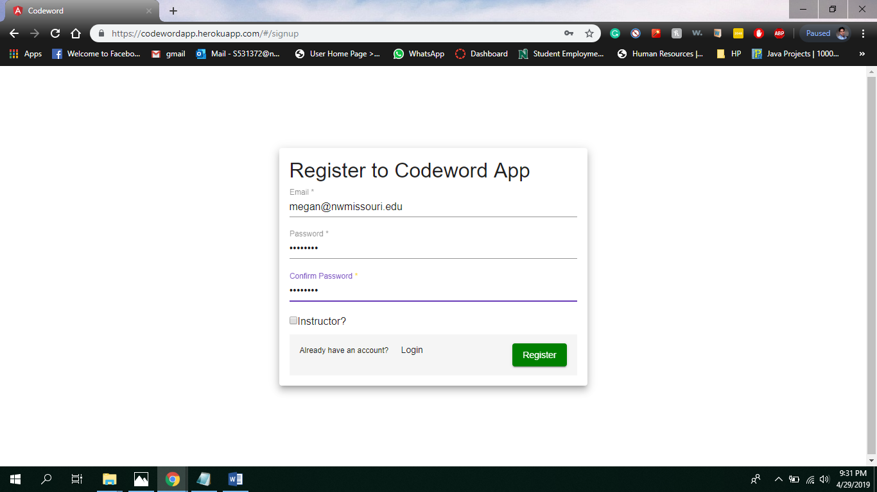

1. Enter the email-id and password.

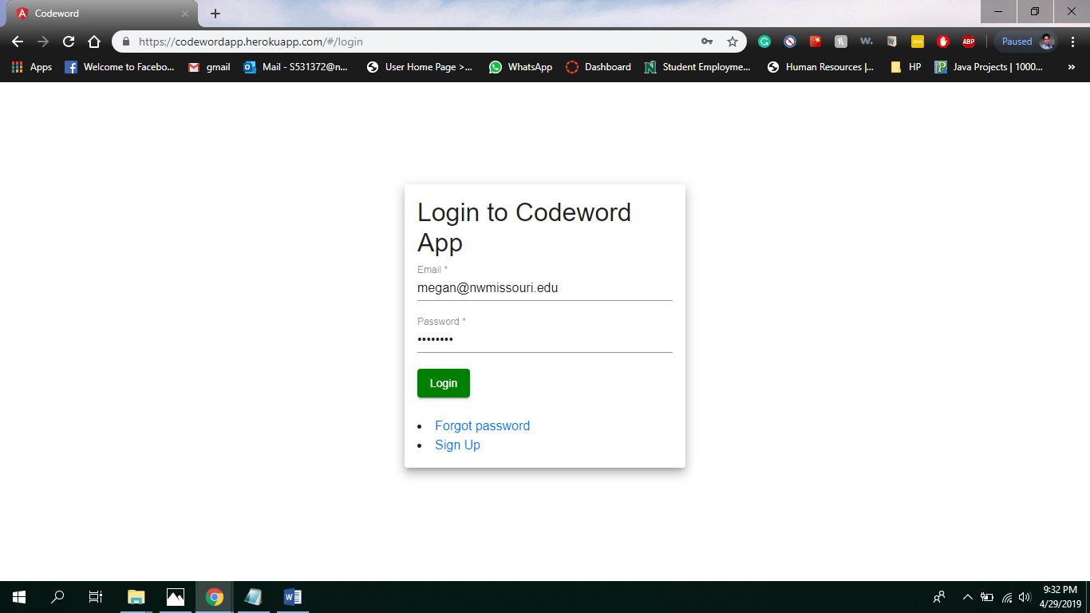

1. A confirmation message will be shown as a pop-up

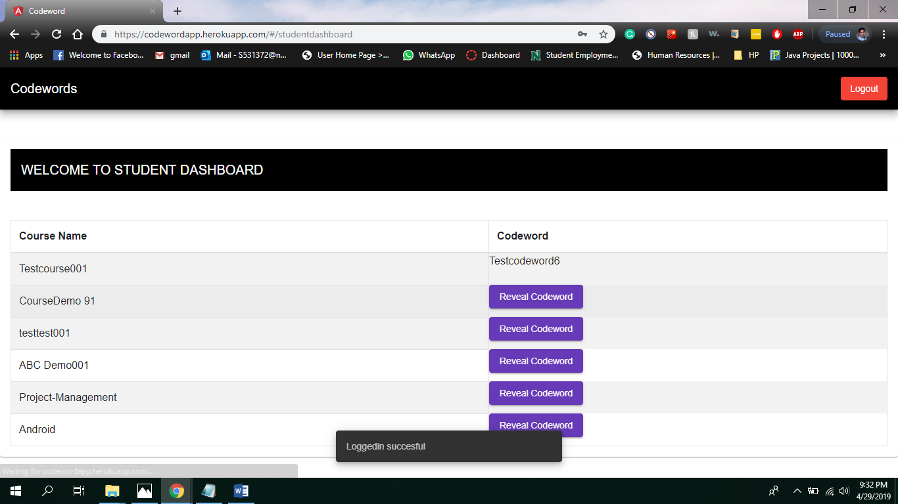

1. View of Student Dashboard showing courses and hidden codeword

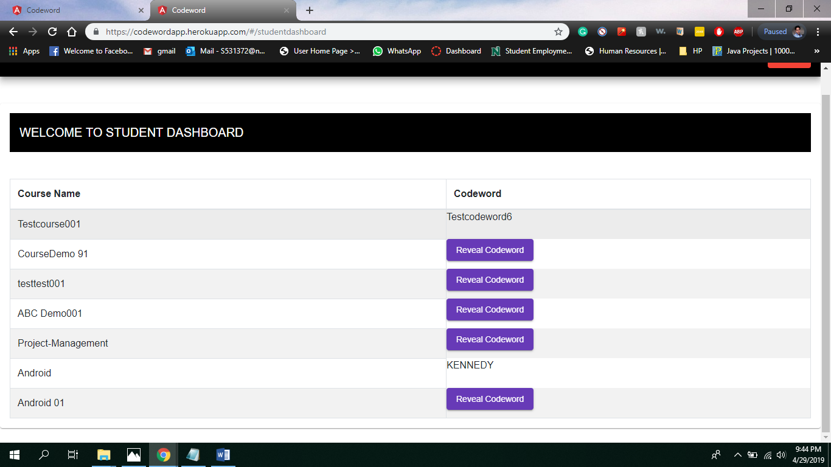

1. Reveling of codeword of Android course by clicking Reveal Codeword button

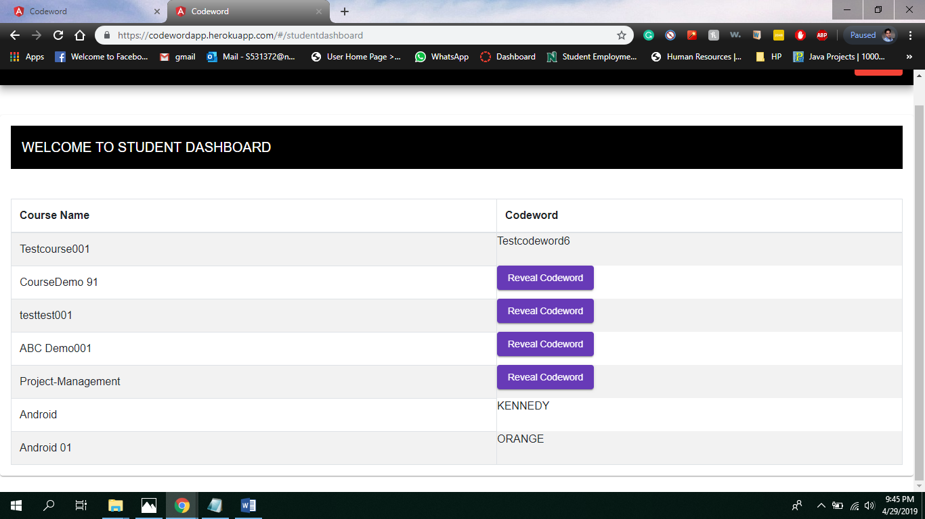

**Step7 : Re- Viewing the acknowledge Status**

Acknowledge Status after Student Viewing the status

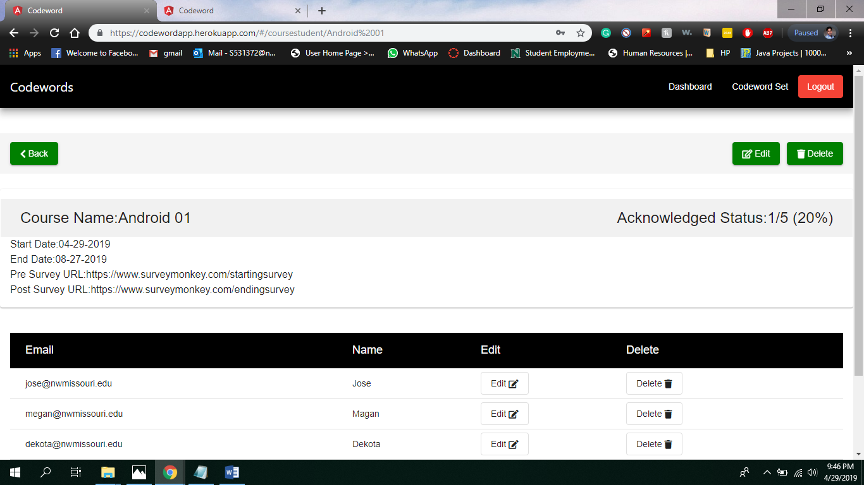

**Step 8: Logging Out of the website**

